Grade 7 Accelerated · Unit 6 · Thread B · Day 1  Angle Pairs: Supplementary, Complementary, Vertical, Adjacent  Question Bank 6.T1 ANSWER KEY | Name  Date  Period

Show your work. Circle your final answer.
For questions 1 through 4, find the angle.
1. The complement of 17°
73°
90 − 17.

2. The supplement of 95°
85°
180 − 95.

3. The angle vertical to a 128° angle
128°
Vertical angles are equal.

4. The angle that makes a linear pair with a 41° angle
139°
180 − 41.

For questions 5 through 7, find x and the angles.
5. 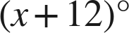 and 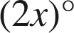 are complementary.
x = 26; 38° and 52°
3x + 12 = 90.

6. 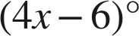 and 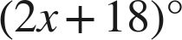 are a linear pair.
x = 28; 106° and 74°
6x + 12 = 180.

7. Vertical angles measure 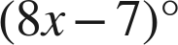 and 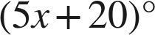.
x = 9; each 65°
3x = 27.

Choose one.
8. Angles M and N are supplementary, and angle M is 64°. What is angle N?
○ A. 26°
● B. 116°
○ C. 64°
○ D. 244°
B
180 − 64.

9. Vertical angles measure 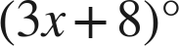 and 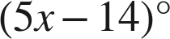. A student answers 11. What did the student find?
○ A. the angle
● B. the value of x
○ C. the supplement
○ D. the complement
B
x = 11; each angle is 3(11) + 8 = 41°.

